T

**Emkan’s retail lending platform los and lms implementation**

August 22, 2024

Drop 1 LMS LLD

www.ejada.com

## Table of Contents

Table of Contents 2

Document Version History 3

Document Review & Approval History 3

Table of Figures 4

1 LMS Activities - Micro Finance, Top up, Refinance 6

1.1 LMS-Integration Touch Points 16

# Document Version History

|  |  |  |  |
| --- | --- | --- | --- |
| **Ver** | **Date** | **Author** | **Change Description** |
| 1.0 | 22/08/2024 | Mohammed Omar Eid | Version 1 |

Table 1 Document Version History

# Document Review & Approval History

|  |  |  |  |  |
| --- | --- | --- | --- | --- |
| **Ver** | **Reviewer** | **Approver** | **Review Date** | **Approval Date** |
| 1.0 |  |  |  |  |

Table 2 Document Review & Approval History

## Table of Figures

Figure 28 Draft Application Stage PF 6

Figure 29 Personal Information PF 8

Figure 30 Qarar Decision PF 10

Figure 31 Underwriter Approval PF 11

Figure 32 Offering Stage PF 13

Figure 33 Loan Execution PF 16

Figure 34 Loan Disbursement PF 18

Figure 35 Draft Application Stage RF 19

Figure 36 Personal Information RF 22

Figure 37 Credit Decisioning RF 24

Figure 38 Underwriter Approval RF 25

Figure 39 Initial offer 27

Figure 40 Loan Execution 31

Figure 41 Loan Disbursement 33

Figure 42 Repayment through payment gateways 42

Figure 43 Mandate Request 45

Figure 44 Repayment through Direct deduction 46

Figure 45 Loan Amendments 48

**LMS EXECUTION FLOW**

# LMS Activities - Micro Finance, Top up, Refinance

**Perform Repayment**

Transact to identify the loans to be repaid the current month based on the information passed by the NewGen. Emkan to provide 2 options for repayment of loan:

1. Repayment through different payment gateways (for all customer – ARB and non-ARB customers) via EMKAN website and mobile app
2. Repayment through direct deduction (only for ARB customers)

**1-Payment through payment gateway**

Transact to integrate with Digital channels (Web/mobile) to provide the option of different payment instruments and to share Repayment schedule and due and past due instalment.

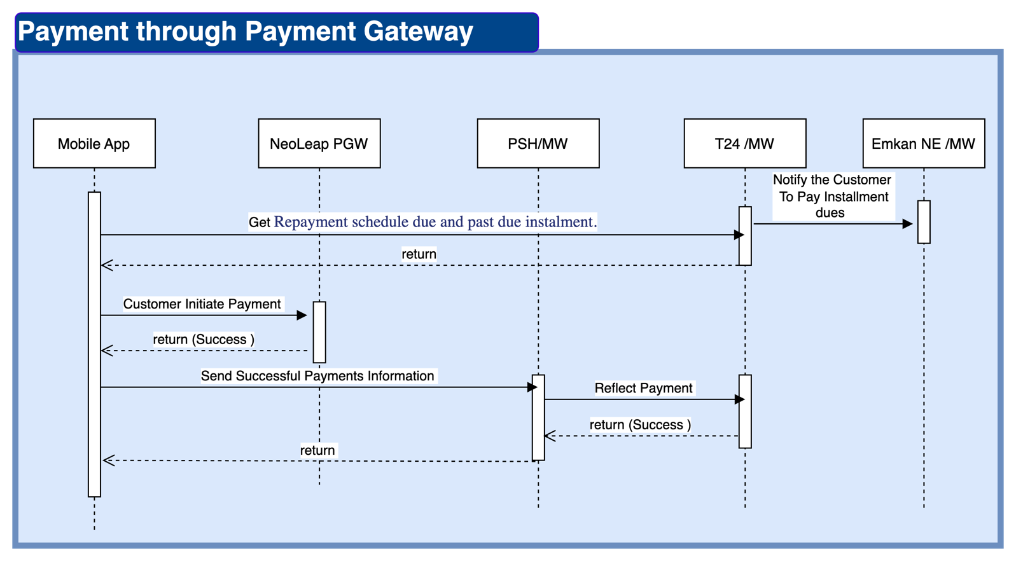

Figure 42 Repayment through payment gateways

|  |  |  |  |  |  |
| --- | --- | --- | --- | --- | --- |
| **Action** | **Provider** | **Consumer** | **Request** | **Response** | **Type** |
| Notify the Customer  To Pay Installment dues | EMKAN NE | T24 | Notification ID,  Customer ID | Status | API |
| Get Repayment schedule due and past due instalment. | T24 | Channel | Contract ID | Repayment schedule due and past due instalment | API |
| Reflect Payment | T24 | EMKAN PSH | Contract ID, payment status, payment instrument and payment reference | Status | API |

**2-Payment through Direct deduction**

1. LMS Transact to provide data to TDH/EDH to build a view for current month DD requests to be sent to ARB.

On the 25 of the months, EMKAN internal component (Micro service) or Incorta will use this view to build the DD request file to be sent to ARB.

ARB will execute the DD request starting 27th of the month + replay for next 5 business days.

1. LMS Transact to provide data to TDH/EDH to build a view for current DD requests already sent to ARB and paid in between with different channels. EMKAN internal component (Micro service) or Incorta will use this view to build the DD cancellation request file to be sent to ARB.
2. ARB will share the DD cancellation feedback to Emkan. This file is not required to be consumed by LMS Transact.
3. ARB will share daily from 27th of the month + next 5 business days DD feedback to capture DD execution status. This file is transformed into API calls to LMS Transact via decryption batch.

LMS Transact will consume this call and trigger auto refund check process – refer to BRD02-14.

If customer is eligible, LMS Transact is expected to send a refund request to ARB.

If not, LMS Transact to update installment as paid and book related accounting entries. – refer to accounting cycle.

**Mandate Request**

When loan is reaching disbursement stage, Emkan systems are required to generate a report (format to be shared by Emkan and attached in requirement) (once a month on 23th of month – date can be changed) to provide all new Direct deduction mandates for creation in ARB (customers who provided consent during origination journey during current month). This request must be sent only one time during loan application process.

Direct deduction mandate data:

|  |  |
| --- | --- |
| Field | Sample value |
| GINATOR_ID | 1010501239101 |
| MANDATE_REFERENCE | 14327427 |
| CUST_ACCT | 1,54608E+14 |
| THRESHOLD_AMOUNT | 1507.66 |
| END_DATE | 20290227 |
| NO_OF_DEBITS | 0 |
| DT_OF_LAST_DBT_C/A |  |
| AMT_OF_LAST_DBT | 0 |
| MANDATE_STATUS | B |
| PARTY NAME | مقبل عقيل    الشمري |
| PARTY ADDRESS1 |  |
| PARTY ADDRESS2 |  |
| PARTY ADDRESS3 |  |
| START DATE | 2024 |

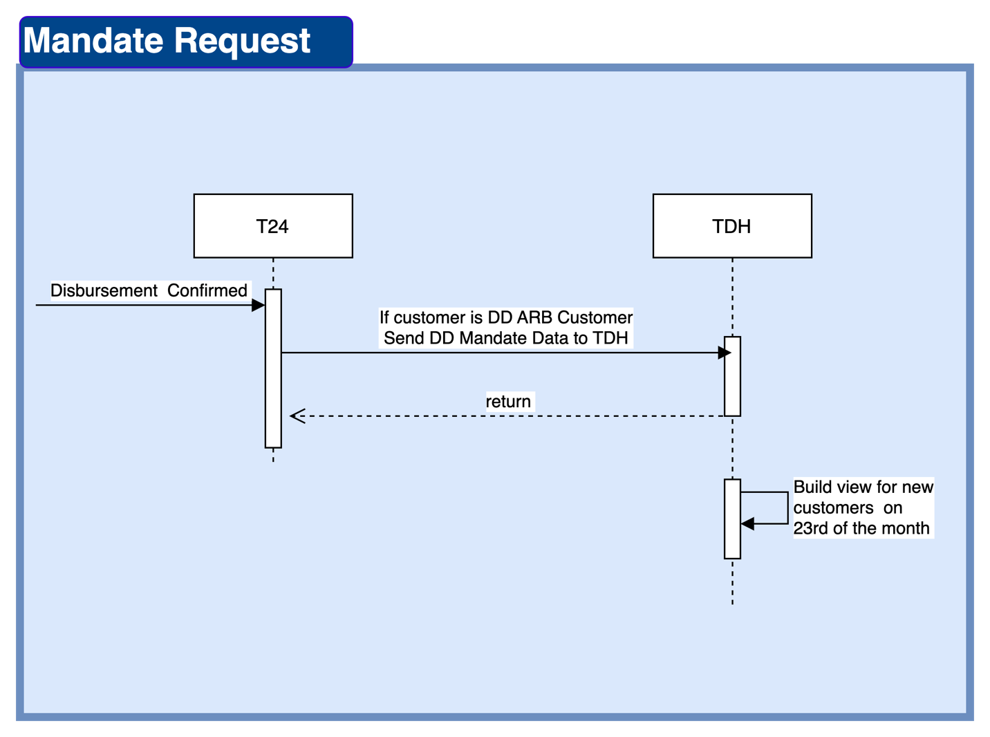

Figure 43 Mandate Request

|  |  |  |  |  |  |
| --- | --- | --- | --- | --- | --- |
| **Action** | **Provider** | **Consumer** | **Request** | **Response** | **Type** |
| Send DD Mandate Data to TDH | T24 | TDH | If customer is DD ARB Customer Send DD Mandate Data to TDH | Status | Event Disbursement Confirmed |
| Build view for new customers  on 23rd of the month | TDH | Incorta | TBD in FSD | Mandate File View |  |

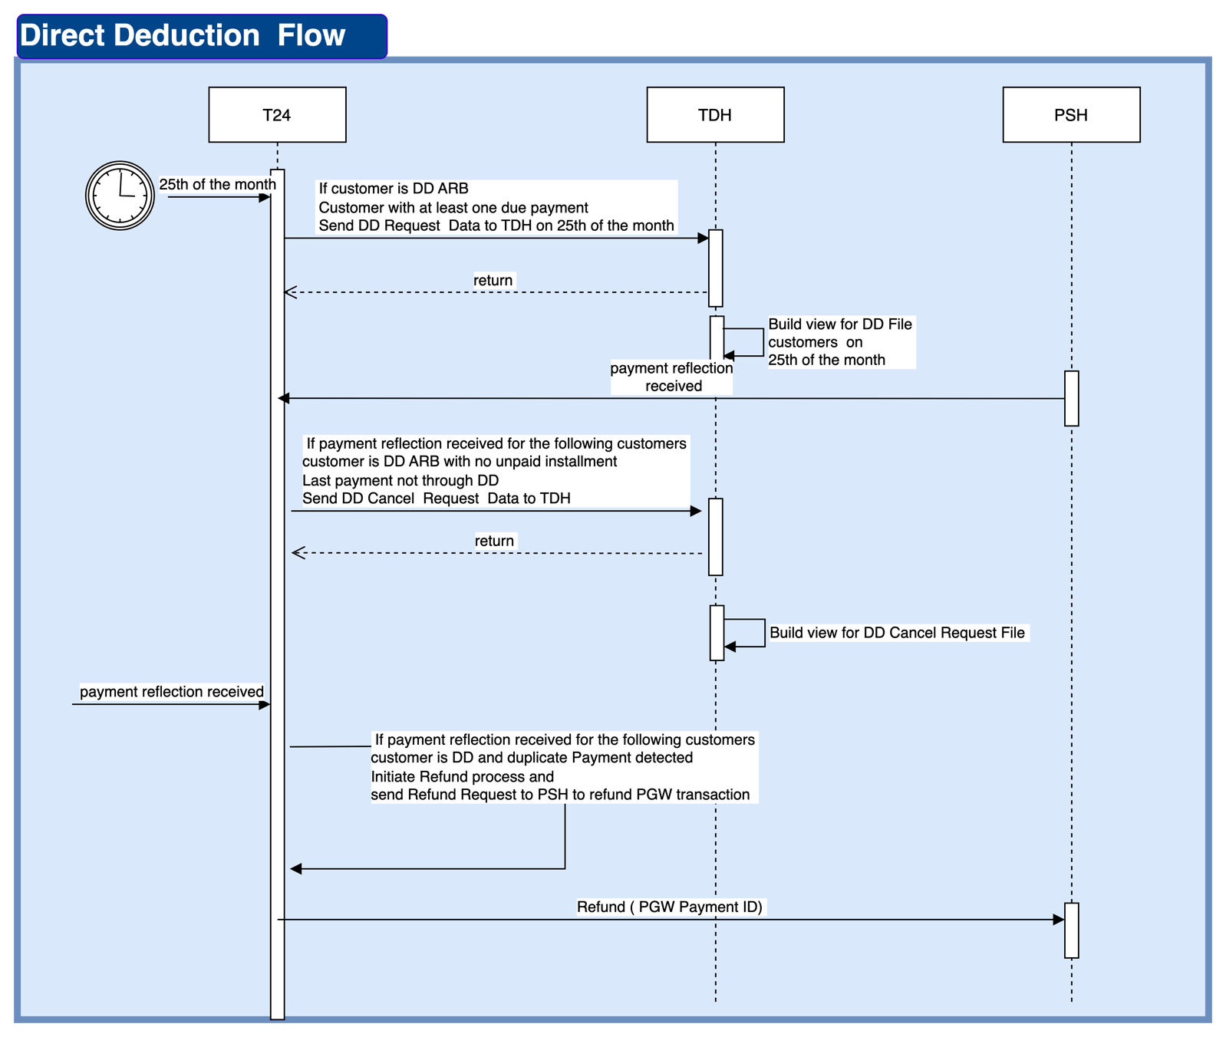

Figure 44 Repayment through Direct deduction

|  |  |  |  |  |  |
| --- | --- | --- | --- | --- | --- |
| **Action** | **Provider** | **Consumer** | **Request** | **Response** | **Type** |
| Send DD Request  Data to TDH on 25th of the month | T24 | TDH | If customer is DD ARB   Customer with at least one due payment   Send DD Request  Data to TDH on 25th of the month | Status | Event 25th of the month |
| Build view for DD File  customers  on 25th of the month | TDH | Incorta | TBD in FSD | DD File View |  |
| Send DD Cancel  Request  Data to TDH | T24 | TDH | If payment reflection received for the following customers  customer is DD ARB with no unpaid installment  Last payment not through DD  Send DD Cancel  Request  Data to TDH | Status | Event payment reflection received |
| Build view for DD Cancel Request File | TDH | Incorta | TBD in FSD | DD Cancel file view |  |
| nitiate Refund process and  send Refund Request to PSH to refund PGW transaction | PSH | T24 | If payment reflection received for the following customers  customer is DD and duplicate Payment detected  nitiate Refund process and  send Refund Request to PSH to refund PGW transaction |  | API PGW Payment ID |

**Loan Amendments**

Loan amendment can only be done via Emkan back office. Customer can only request to amend the loan through customer care/branch , Emkan to accept the loan amendment request at the branch or through customer care, select the loan of the customer and check for simulation, if required

If simulation is not required, Emkan to make amendments as per the list of activities allowed to be amended, transact to integrate with Nafith for generation of new Promissory note with the amended details and close the existing one in case of changes in loan amount, tenure, profit and amends the loan.

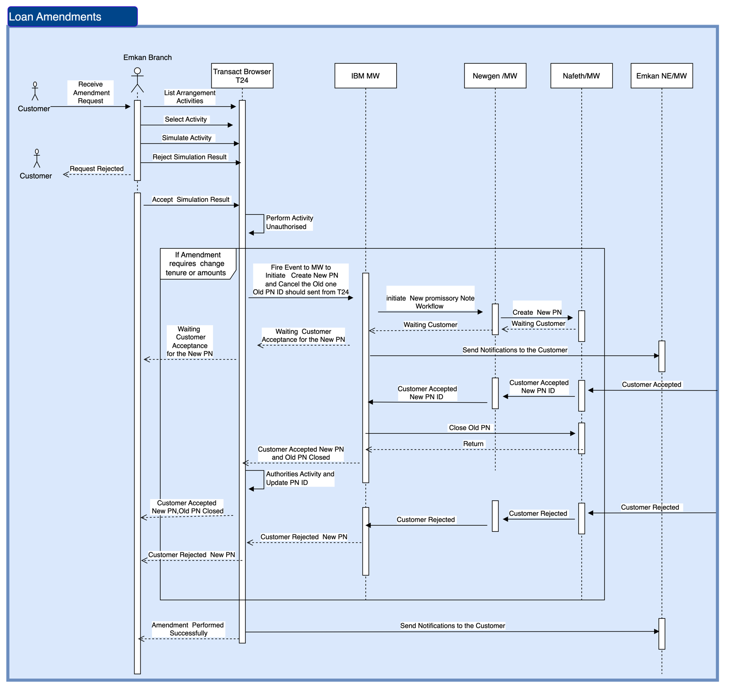

Figure 45 Loan Amendments

|  |  |  |  |  |  |
| --- | --- | --- | --- | --- | --- |
| **Action** | **Provider** | **Consumer/Listener** | **Request** | **Response** | **Type** |
| Create New PN and Close the Old one | T24 | IBM MW | Contract ID,  Old PN ID | Status | Event |
| Initiate New promissory Note Workflow | Newgen | IBM MW | Contract ID | Status | Event |
| Waiting  Customer Acceptance for the New PN | IBM MW | Newgen | Contract ID, payment status, payment instrument and payment reference | Status | API |
|  |  |  |  |  |  |

**T24 Customer Onboarding – LOS Application Stage**

This will be the very first stage in loan origination system workflow and all the new application will be created at this stage, either the source is “Digital” or “Branch – Walkin”.

**T24 Islamic Contract creation – LOS Loan Execution Stage**

At this stage LMS will receive instructions to create Islamic contract defining the Islamic product, commodity type & commodity broker/vendor

**T24 Commodity Purchase – LOS Loan Execution Stage**

At this stage LMS will receive instructions to execute buying commodity action on the previously created IS contract.

**T24 AA Finance Creation – LOS Loan Execution Stage**

At this stage LMS will receive instructions to create AA Finance/Loan contract linked to the previously created IS contract & LOS application ID

**T24 Commodity Sell – LOS Loan Execution Stage**

At this stage LMS will receive instructions to sell the commodity on behalf of customer (based on the product type)

**T24 Disburse to customer / Goods Delivery – LOS Loan Disbursement Stage**

At this stage LMS will receive instructions to credit customer account or deliver the goods to customer (based on the product type)

**T24 Disburse to customer / Goods Delivery – LOS Loan Disbursement Stage**

At this stage LMS will receive instructions to credit customer account or deliver the goods to customer (based on the product type)

**T24 Monthly Repayment process – Direct Deduction file**

**-** T24 will create an EOD file with all the outstanding instalments in the system

- After processing the file inside Emkan by Payment Hub, the settled instalments/amount will be sent back to T24 to update the settled instalments

**T24 Early settlement process – Payment Order**

- Full: incase T24 receives full settlement instructions, T24 will calculate 3 months profit and be added to the outstanding principal + fees, then return the calculated amount to be used to execute the transaction

- Partial:

### T24 Customer Enquiry – LOS Application Stage

This will be the very first stage in loan origination system workflow and all the new application will be created at this stage, either the source is “Digital” or “Branch – Walkin”.

### T24 Islamic Contract creation – LOS Loan Execution Stage

At this stage LMS will receive instructions to create Islamic contract defining the Islamic product, commodity type & commodity broker/vendor

### T24 Commodity Purchase – LOS Loan Execution Stage

At this stage LMS will receive instructions to execute buying commodity action on the previously created IS contract.

### T24 AA Finance Creation – LOS Loan Execution Stage

At this stage LMS will receive instructions to create AA Finance/Loan contract linked to the previously created IS contract & LOS application ID

### T24 Commodity Sell – LOS Loan Execution Stage

At this stage LMS will receive instructions to sell the commodity on behalf of customer (based on the product type)

### T24 Disburse to customer / Goods Delivery – LOS Loan Disbursement Stage

At this stage LMS will receive instructions to credit customer account or deliver the goods to customer (based on the product type)

### T24 Disburse to customer / Goods Delivery – LOS Loan Disbursement Stage

At this stage LMS will receive instructions to credit customer account or deliver the goods to customer (based on the product type)

### T24 Monthly Repayment process – Direct Deduction file

- T24 will create an EOD file with all the outstanding instalments in the system

- After processing the file inside Emkan by Payment Hub, the settled instalments/amount will be sent back to T24 to update the settled instalments

### T24 Early settlement process – Payment Order

- Full: incase T24 receives full settlement instructions, T24 will calculate 3 months profit and be added to the outstanding principal + fees, then return the calculated amount to be used to execute the transaction

## LMS-Integration Touch Points

|  |  |  |  |  |  |  |  |
| --- | --- | --- | --- | --- | --- | --- | --- |
| **Group** |  |  | **Description** | **System /s** | **TP Type** | **Real-time Y/N** | **Sample In/Out Parameters/fields** |
| Customer Onboarding | 1 | API | Customer Enquiry | Newgen | Enquiry | Y | * Customer ID/Iqama ID * Customer Name * Address |
| 2 | API | Customer Creation | Newgen | Create | Y |
| 3 | API | Customer Update | Newgen | Update | Y |
| Islamic & Financing Contracts | 4 | API | IS contract Creation | Newgen | Create | Y | * IS contract ID * IS Product Code * Amount |
| 5 | API | IS Contract Enquiry | Newgen | Enquiry | Y |
| 6 | API | Commodity Buy | Newgen | Update | Y |
| 7 | API | Commodity Sell | Newgen | Update | Y |
| 8 | API | Loan Creation | Newgen | Create | Y | * Application ID * Product Code * Arrangement ID * Amount * Repayment schedule start date |
| 9 | API | Loan Update | Newgen | Update | Y |
| 10 | API | Contract Cancelation | Newgen | Update | Y |
| Loan Disbursement | 11 | API | Loan disbursement | Newgen, Emkan Pay hub | Update, Transaction | Y | * Arrangement ID * Amount * VIBAN |
| Loan Repayment | 12 | API | Loan Repayment (single, bulk, Partial, Full, In advance) | Emkan pay hub | Transaction | Y | * Arrangement ID * Amount * Bill date |
| 13 | API | Direct deductions | Emkan pay hub | Transaction | N |
| EXUS Collection System | 14 | COB File | Collection reports | Emkan collection system | Report | N | * Arrangement ID * Amount * Bill date * No of past due bills |
| SIMAH | 15 | COB File | SIMAH reports | SIMAH | Report | N | Customer exposure |
| Provisioning | 16 |  | Risk & Provisioning update | SAS | Enquiry & Transaction | N | * Customer ID * Arrangement ID * Outstanding balance * No of past dues |
| GL | 17 | COB File | GL entries replication | Oracle GL | Data | N | Console key balances after COB |
| Promissory Note |  |  |  |  |  |  |  |
| Loan Details | 18 | API | to share Repayment schedule and due and past due instalment | Channel | Enquiry | Y |  |
| Direct deductions | 19 | Event | provide data to TDH to build a view for current month DD requests to be sent to ARB.  On the 25 of the month | TDH | Enquiry | N | * Arrangement ID * Due installment   + Amount   + Bill date * Past Due installment List   {   * Amount * Bill date   } |
|  |  |  |  |  |  |  |  |